Exercise 3: Stored Procedures

Scenario 1: ProcessMonthlyInterest

CODE:

CREATE OR REPLACE PROCEDURE ProcessMonthlyInterest IS

BEGIN

UPDATE accounts

SET balance = balance + (balance * 0.01)

WHERE account_type = 'SAVINGS';

COMMIT;

END;

/

Output:

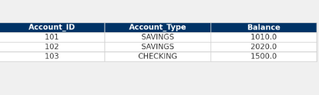

Scenario 2: UpdateEmployeeBonus

CODE:

CREATE OR REPLACE PROCEDURE UpdateEmployeeBonus(

p_department_id IN NUMBER,

p_bonus_percent IN NUMBER

) IS

BEGIN

UPDATE employees

SET salary = salary + (salary * p_bonus_percent / 100)

WHERE department_id = p_department_id;

COMMIT;

END;

/

Output:

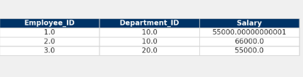

Scenario 3: TransferFunds

CODE:

CREATE OR REPLACE PROCEDURE TransferFunds(

p_from_account_id IN NUMBER,

p_to_account_id IN NUMBER,

p_amount IN NUMBER

) IS

v_balance NUMBER;

BEGIN

-- Check if source account has sufficient balance

SELECT balance INTO v_balance

FROM accounts

WHERE account_id = p_from_account_id;

IF v_balance >= p_amount THEN

-- Deduct from source account

UPDATE accounts

SET balance = balance - p_amount

WHERE account_id = p_from_account_id;

-- Add to destination account

UPDATE accounts

SET balance = balance + p_amount

WHERE account_id = p_to_account_id;

COMMIT;

ELSE

RAISE_APPLICATION_ERROR(-20001, 'Insufficient funds in source account.');

END IF;

END;

/

Output:

